**第二劑BNT疫苗學生接種前準備**

**必帶**

\***健保卡、原子筆、水壺**

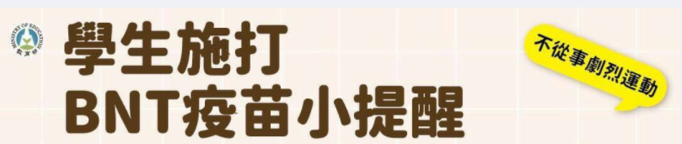

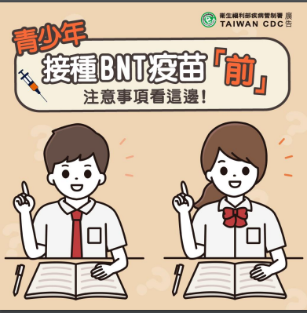

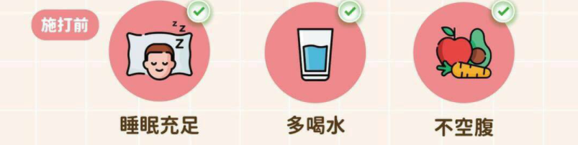

穿著

**\*營養均衡、務必用餐**

**充足水分、心情放輕鬆**

**\*洋蔥是穿著，裡面穿著短袖體育服**

**外面穿前開式體育服外套，方便露出上臂，讓疫苗接種作業順暢**

**身心準備**

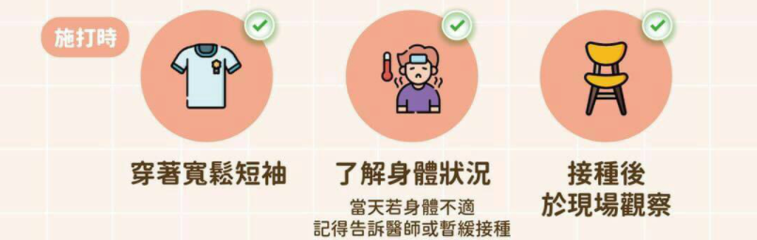

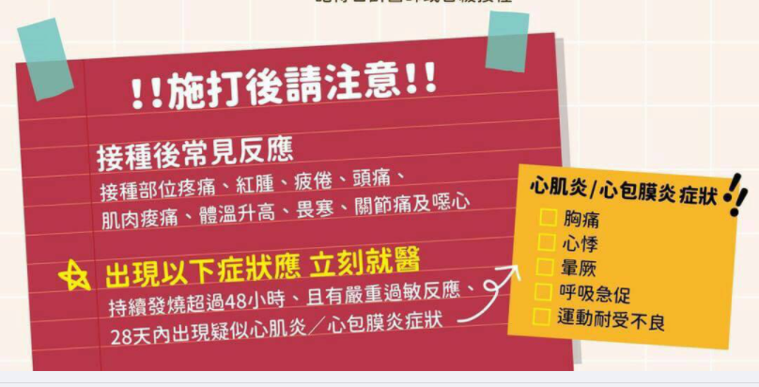

**第二劑BNT疫苗各班接種時間表**

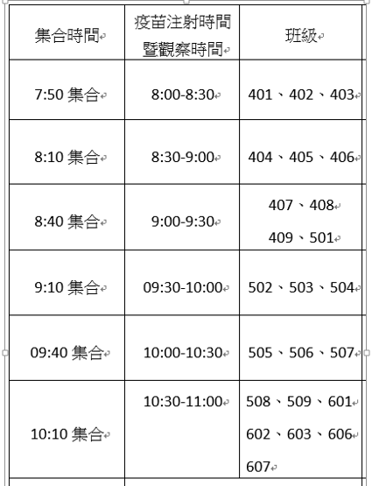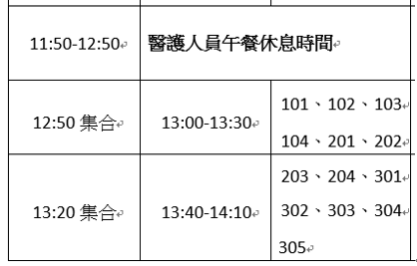

**成德高中校園BNT疫苗集中接種**

**學生活動中心 場地配置圖**

|  |  |  |  |  |  |  |  |  |  |  |  |  |  |  |  |  |  |  |  |  |  |  |  |  |  |  |  |  |  |  |  |  |  |  |  |  |  |  |  |  |  |  |  |  |  |  |  |  |  |  |  |  |  |  |  |  |  |  |  |  |  |  |  |  |  |  |  |  |  |  |  |  |  |  |  |  |  |  |  |  |  |  |  |  |  |  |  |  |  |  |  |  |  |  |  |  |  |  |  |  |  |  |  |  |  |  |  |  |
| --- | --- | --- | --- | --- | --- | --- | --- | --- | --- | --- | --- | --- | --- | --- | --- | --- | --- | --- | --- | --- | --- | --- | --- | --- | --- | --- | --- | --- | --- | --- | --- | --- | --- | --- | --- | --- | --- | --- | --- | --- | --- | --- | --- | --- | --- | --- | --- | --- | --- | --- | --- | --- | --- | --- | --- | --- | --- | --- | --- | --- | --- | --- | --- | --- | --- | --- | --- | --- | --- | --- | --- | --- | --- | --- | --- | --- | --- | --- | --- | --- | --- | --- | --- | --- | --- | --- | --- | --- | --- | --- | --- | --- | --- | --- | --- | --- | --- | --- | --- | --- | --- | --- | --- | --- | --- | --- | --- | --- |
| **衛教宣導**  **行政工作區**  **疫苗抽取**  **請保持安靜**  **身體不舒服請**  **立即舉手反應**  **疫**  **苗**  **接**  **種**  **注**  **射**  **區**   |  |  |  |  |  |  |  |  |  |  |  |  | | --- | --- | --- | --- | --- | --- | --- | --- | --- | --- | --- | --- | | 1 | 2 | 3 | 4 | 5 | 6 | 7 | 8 | 9 | 10 | 11 | 12 | | 13 | 14 | 15 | 16 | 17 | 18 | 19 | 20 | 21 | 22 | 23 | 24 | | 25 | 26 | 27 | 28 | 29 | 30 | 31 | 32 | 33 | 34 | 35 | 36 |   **班級疫苗接種留觀區**  **注射完請依序入座觀察15分鐘**  **方可離開**   |  |  |  |  |  |  |  |  |  |  |  |  | | --- | --- | --- | --- | --- | --- | --- | --- | --- | --- | --- | --- | | 1 | 2 | 3 | 4 | 5 | 6 | 7 | 8 | 9 | 10 | 11 | 12 | | 13 | 14 | 15 | 16 | 17 | 18 | 19 | 20 | 21 | 22 | 23 | 24 | | 25 | 26 | 27 | 28 | 29 | 30 | 31 | 32 | 33 | 34 | 35 | 36 |   **班級疫苗接種留觀區**   |  |  |  |  |  |  |  |  |  |  |  |  | | --- | --- | --- | --- | --- | --- | --- | --- | --- | --- | --- | --- | | 1 | 2 | 3 | 4 | 5 | 6 | 7 | 8 | 9 | 10 | 11 | 12 | | 13 | 14 | 15 | 16 | 17 | 18 | 19 | 20 | 21 | 22 | 23 | 24 | | 25 | 26 | 27 | 28 | 29 | 30 | 31 | 32 | 33 | 34 | 35 | 36 |   **消防醫護休息區**  **資料核對工作區**    **暈針休息區** |

**全班團進團出，請在指定時間至活動中心二樓等待區，志工老師協助意願書、黃卡發放，由防疫股長協助體溫測量。**

**如何保護自己不被感染，8個小訣竅提醒您**